**FORECASTING COMMODITY PRICES**

## A PROJECT REPORT

***Submitted by,***

**Mr. G M VIANY SREEKAR REDDY - 20201CSE0858**

**Ms. SAHANA GOWDA KR - 20201CSE0902**

**Ms. BHAVANA V - 20201CSE0886**

**Ms. ANKITHA MORE B - 20201CSE0873**

**Ms. POOJITHA G - 20201CSE0876**

### *Under the guidance of,*

**Dr. Prasad P.S**

**Assistant Professor**

***Department of Computer Science and Engineering in partial fulfillment for the award of the degree of***

**BACHELOR OF TECHNOLOGY**

**IN**

**COMPUTER SCIENCE AND ENGINEERING,**

**At**



**PRESIDENCY UNIVERSITY**

**BENGALURU**

**JANUARY 2024**

**PRESIDENCY UNIVERSITY**

**SCHOOL OF COMPUTER SCIENCE ENGINEERING**

**CERTIFICATE**

This is to certify that the Project report **“FORECASTING COMMODITY PRICES”** being submitted by **“G M VINAY SREEKAR REDDY – 20201CSE0858, SAHANA GOWDA KR - 20201CSE0902, BHAVANA V – 20201CSE0886, ANKITHA MORE B – 20201CSE0873, POOJITHA G – 20201CSE0876”**, in partial fulfillment of the requirement for the award of the degree of **Bachelor of Technology in Computer Science and Engineering** is a bonafide work carried out under my supervision.

|  |  |
| --- | --- |
| **Dr. Prasad P.S**  Assistant Professor-CSE  School of CSE&IS  Presidency University | **Dr. PALLAVI R**  Associate Professor& HOD  School of CSE&IS  Presidency University |

|  |  |  |
| --- | --- | --- |
| **Dr. C. KALAIARASAN**  Associate Dean  School of CSE&IS  Presidency University | **Dr. L. SHAKKEERA**  Associate Dean  School of CSE&IS  Presidency University | **Dr. SAMEERUDDIN KHAN** Dean  School of CSE&IS  Presidency University |

**PRESIDENCY UNIVERSITY**

**SCHOOL OF COMPUTER SCIENCE ENGINEERING & INFORMATION SCIENCE**

**DECLARATION**

We hereby declare that the work, which is being presented in the project report entitled **FORECASTING COMMODITY PRICES** in partial fulfilment for the award of Degree of **Bachelor of Technology** in **Computer Science and Engineering**, is a record of our investigations carried out under the guidance of **Dr. Prasad P.S, Assistant Professor**, **School of Computer Science Engineering, Presidency University, Bengaluru.**

We have not submitted the matter presented in this report anywhere for the award of any other Degree.

|  |  |  |
| --- | --- | --- |
| **ID** | **Name** | **Signature** |
| **20201CSE0858** | **G M Vinay Sreekar Reddy** |  |
| **20201CSE0902** | **Sahana Gowda KR** |  |
| **20201CSE0886** | **Bhavana V** |  |
| **20201CSE0873** | **Ankitha More B** |  |
| **20201CSE0876** | **Poojitha G** |  |

|  |  |
| --- | --- |
|  |  |

**ABSTRACT**

**The task of predicting commodity prices is one of the most difficult tasks in the world. It is an essential part of financial markets and a key factor in global economic stability. However, commodity prices are subject to a great deal of volatility due to a variety of factors, including geopolitical events and supply and demand dynamics. This makes accurate predictions a difficult task. In this study, we use sophisticated statistical models and advanced machine learning techniques to improve commodity price forecasting accuracy and reliability.**

**Our methodology involves the use of historical price data and market indicators, as well as relevant economic variables, to create predictive models. The use of time series analysis and machine learning algorithms, as well as econometric models, form the basis of our approach. We use cutting-edge technologies to identify patterns, trends, and key drivers that affect commodity prices across different markets.**

**We focus on key commodities like oil, gold, and agricultural products, taking into account their economic importance and their influence on global trade. We also look at how emerging technologies such as AI and big data analytics can help refine forecasting models and adapt to changing market conditions.** **Not only does the research aim to enhance short-term price forecasts, but it also aims to provide valuable insight into long-term patterns and market dynamics.**

**Keywords:** **Commodity prices, Agricultural authorities, Commodity market data, forecasting, linear regression, Python, Jupyter Notebook.**

**ACKNOWLEDGEMENT**

First of all, we are indebted to the **GOD ALMIGHTY** for allowing me to excel in our efforts to complete this project on time.

We express our sincere thanks to our respected dean **Dr. Md. Sameeruddin Khan**, Dean, School of Computer Science Engineering & Information Science, Presidency University for getting us permission to undergo the project.

We record our heartfelt gratitude to our beloved Associate Deans **Dr. Kalaiarasan C and Dr. Shakkeera L,** School of Computer Science Engineering & Information Science, Presidency University, and Dr. “**Dr. Pallavi R.**”, Head of the Department, School of Computer Science Engineering & Information Science, Presidency University for rendering timely help for the successful completion of this project.

We are greatly indebted to our guide **Dr. Prasad P.S, Assistant Professor**, School of Computer Science Engineering & Information Science, Presidency University for his inspirational guidance, and valuable suggestions and for providing us a chance to express our technical capabilities in every respect for the completion of the project work.

We would like to convey our gratitude and heartfelt thanks to the University Project-II Coordinators **Dr. Sanjeev P Kaulgud, Dr. Mrutyunjaya MS,** and also the department Project Coordinators **“Mr. Zia Ur Rahman, Mr. Peniel John Whistely”**.

We thank our family and friends for the strong support and inspiration they have provided us in bringing out this project.

**G M Vinay Sreekar Reddy**

**Sahana Gowda K R**

**Bhavana V**

**Ankitha More B**

**Poojitha G**

**LIST OF TABLES**

|  |  |  |  |
| --- | --- | --- | --- |
| **Sl. No.** | **Table Name** | **Table Caption** | **Page No.** |
| 1 | Table 1.1 | Literature Survey | 6 |
| 2 | Table 1.2 | Literature Survey | 7 |
| 3 | Table 1.3 | Literature Survey | 8 |

**LIST OF FIGURES**

|  |  |  |  |
| --- | --- | --- | --- |
| **Sl. No.** | **Figure Name** | **Caption** | **Page No.** |
| 1 | Figure 1.1 | MODULE DIAGRAM | 15 |
| 2 | Figure 1.2 | ARCHITECTURE DIAGRAM | 18 |
| 3 | Figure 1.3 | SCREENSHOTS | 36 |

**TABLE OF CONTENTS**

|  |  |  |
| --- | --- | --- |
| **CHAPTER** | **TITLE** | **PAGE NO** |
|  | **CERTIFICATE**  **DECLARATION**  **ABSTRACT**  **ACKNOWLEDGEMENT** |  |
| **1** | **INTRODUCTION**   1. **BACKGROUND**   **1.2 OBJECTIVES**  **1.3 SCOPE AND SIGNIFICANE**  **1.4 OUTLINE** | **1** |
| **2** | **LITERATURE SURVEY** | **6** |
| **3** | **RESEARCH GAPS OF EXISTING METHODS** | **9** |
| **4** | **PROPOSED METHODOLOGY** | **11** |
| **5** | **OBJECTIVES** | **13** |
| **6** | **SYSTEM DESIGN/IMPLEMENTATION**  **6.1 MODULE DIAGRAM**  **6.2 ARCHITECTURE DIAGRAM** | **15** |
| **7** | **TIMELINE FOR EXECUTION OF PROJECT** | **22** |
| **8** | **OUTCOMES**  **8.1 OUTCOMES** | **25** |
| **9** | **RESULTS AND DISCUSSIONS**  **9.1 RESULTS**  **9.2 DISCUSSIONS** | **26** |
| **10** | **CONCLUSINON** | **30** |

**CHAPTER-1**

**INTRODUCTION**

Forecasting Commodity Prices (FCP) is an important undertaking that has significant implications for the global economy, financial markets, and various stakeholders. Commodity markets, which include a wide range of commodities such as energy resources, metals, agricultural products, and raw materials, play a central role in the functioning of economies around the world. Volatility in commodity prices results from a complex interplay of factors, including geopolitical events, supply and demand dynamics, weather conditions, and global economic trends. Understanding and forecasting changes in commodity prices is paramount for several reasons. Investors rely on accurate forecasts to make informed decisions, companies use them to manage production costs and pricing strategies, and policymakers use them to formulate effective economic policies.

In addition, fluctuations in commodity prices directly affect consumers, as these changes can affect the cost of goods and services. The economic importance of raw materials cannot be overemphasized. For example, crude oil plays an important role in energy markets and has significant impacts on various industries. Similarly, agricultural prices affect food production, supply chains, and international trade. Given the important role of commodities in economic systems, the ability to accurately forecast prices is important to market participants and decision-makers. Equity price forecasting methods are based on fundamental analysis that takes into account supply and demand factors, production methods, and geopolitical factors. However, the increasing complexity of global markets and technological advances have predictably brought about a paradigm shift.

This research explores ways to integrate new technologies such as machine learning and big data analytics into the forecasting process, to improve forecast accuracy and adapt to market trends. In the following sections, we will examine the historical development of commodity markets, describe the main factors affecting commodity prices, and present current forecasting methods. The incorporation of new technologies into traditional forecasting is the focus, setting the stage for the exploration of knowledge and methods derived from research.

* 1. **Background**

Product costs, reflecting the esteem of crude materials and assets, are indispensable to worldwide financial flow. These costs are impacted by a huge number of variables, including geopolitical occasions, supply and request lopsided characteristics, climate conditions, and macroeconomic patterns. The characteristic instability of product markets presents both challenges and openings for advertising members, requiring a nuanced understanding of the strengths at play. The foundation of estimating product costs lies in tending to the requirement for precise forecasts to direct educated decision-making by speculators, businesses, policymakers, and other partners within the confront of ever-changing advertising conditions.

**1.2 Objectives**

The primary objective of Commodity Price Forecasting is to address the uncertainties of commodity markets and provide valuable information for strategic decision-making. Influenced by many factors, selling prices are a dynamic environment that requires accurate foresight to navigate the complexities of international trade, investment, and economic policy Central to our goals is the need to improve forecast accuracy. The goal is to provide market participants with reliable knowledge of future price movements by creating sophisticated models based on historical data and incorporating relevant economic indicators. This objective recognizes the importance of reducing the risks associated with market volatility and enabling investors to make informed decisions. It focuses on identifying the main drivers of commodity prices.

To build powerful forecasting models, it is important to understand a complex web of factors, including geopolitical events, supply and demand dynamics, and technological progress. The goal is to analyze the complexity of commodity markets to gain a deeper understanding of the forces that shape price movements. Another important objective is to explore the role of advanced technologies such as machine learning and big data analysis in the field of commodity price forecasting. The emergence of these technologies will open new avenues to improve forecasting models,

increase adaptability to changing market conditions, and find patterns that traditional methods ignore. This goal recognizes the innovative potential of technology to improve forecasting processes.

The research scope goes beyond individual products and includes a wide variety of energy resources, metals, agricultural products, and raw materials. By taking into account a wide range of products, it is intended to better understand the challenges and opportunities that exist in the different sectors. This comprehensive approach recognizes the interconnectedness of product markets and the need for holistic perspectives. The greatest value of sales forecasting is its ability to provide decision support to various stakeholders. Entrepreneurs can navigate markets with greater confidence, businesses can optimize their supply chain management, and policymakers can create strategies to mitigate economic risks. Finally, the goals of commodity price forecasting are based on a broader perspective to provide valuable insights into global information on economic stability, trade, and financial decision-making.

* 1. **Scope and Significane:**

The scope of commodity price forecasting is a comprehensive analysis of various commodities, including energy resources, metals, agricultural products, and raw materials. This study explores the global nature of commodity markets and recognizes the interconnectedness of economies and the impact of international events on prices. It aims to provide a comprehensive understanding of the challenges and opportunities of various industries, taking into account the various factors affecting commodity price dynamics.

The importance of forecasting commodity prices is most important for various stakeholders. Investors rely heavily on accurate forecasts to make informed trading decisions, optimize their portfolios, and manage risk. Companies, especially those involved in the production and distribution of goods, can benefit from forecasting to optimize supply chain management, pricing strategies, and production planning. Such forecasts are used by decision-makers to formulate strategies that reduce financial risks and promote stable economic growth. The global perspective of this study is very important because of the interconnectedness of economies and the cross-border impact on commodity prices.

Since commodities are the building blocks of industrial production and global trade, anticipating their price changes provides stakeholders with crucial support that enables them to effectively navigate market fluctuations. In an era of technological progress, the integration of cutting-edge technologies such as machine learning and big data analysis will further improve the adaptability of forecasting models to changing market conditions and provide a more comprehensive understanding of commodity price dynamics. Ultimately, the scope and importance of commodity price forecasting lie in its potential to provide valuable insights and methods for navigating the complexities of dynamic commodity markets, facilitating informed decision-making across sectors of the global economy.

* 1. **Outline**

Commodity price forecasting is a multifaceted enterprise that is crucial to the strategic decisions of investors, companies, and policymakers. The background is the historical development of commodity markets and the challenges caused by their inherent volatility. The main goals are to improve forecast accuracy, identify key drivers, and explore advanced technologies such as machine learning. The scope of regulation extends to the comprehensive coverage of various goods, recognizing their global interconnectedness and the importance of international events. Research and its importance is that it can provide decision support to stakeholders, enabling decision makers to make informed business decisions, optimized supply chain management, and risk management strategies.

The outline follows a structured approach that begins with an introduction to contextualize the importance of commodity price forecasts. The following sections cover the background, objectives, scope, and significance, and set the stage for a literature review that examines existing methods and identifies gaps for improvement. The methodology section discusses the research method, which includes data sources, modeling techniques, and technology integration. The following results and analysis present the findings and their implications.

The discussion interprets the results, compares them with existing literature, and concludes with a summary of the most important insights and possible future research

opportunities. With this comprehensive study, the study aims to bring valuable perspectives and methods to commodity price forecasting.

**CHAPTER-2**

**LITERATURE SURVEY**

A literature review is an important part of understanding the current landscape of commodity price forecasting research. This section reviews existing research, methods, and insights related to the topic. By synthesizing and analyzing previous research, it provides a basis for identifying knowledge gaps and opportunities for improvement. The literature review plays a key role in contextualizing the research within the wider academic discourse, guiding the development of methodologies, and shaping the research contribution to the field of commodity price forecasting.

|  |  |  |  |  |  |
| --- | --- | --- | --- | --- | --- |
| **Year** | **Title Name** | **Author Name’s** | **Advantages** | **Disadvantages** | **Methodology** |
| 2014 | Forecasting Palm Oil Prices Using a Wavelet Neural Network Approach | Wang, L., Lin, W., & Zhang, S. | Captures non-linear relationships and trends | Can be computationally expensive, and requires careful parameter tuning | Wavelet Neural Network (WNN) |
| 2015 | A Hybrid Fuzzy Inference System and ARIMA Model for Forecasting Natural Gas Prices | Chen, Y., Li, L., & He, X. | Handles complex relationships, improves forecast accuracy | Increased model complexity, potential overfitting in FIS | Fuzzy Inference System (FIS) combined with ARIMA |

**Table 1.1 Literature Survey**

|  |  |  |  |  |  |
| --- | --- | --- | --- | --- | --- |
| **Year** | **Title Name** | **Author Name’s** | **Advantages** | **Disadvantages** | **Methodology** |
| 2016 | A Spatiotemporal LSTM Model for Forecasting Electricity Prices | Zhang, J., Li, Y., & Li, F. | Captures spatial and temporal dependencies, improves forecasting accuracy | Data-intensive requires domain knowledge for feature selection | Spatiotemporal LSTM with feature selection |
| 2017 | Ensemble Neural Networks for Crude Oil Price Prediction | Zhou, Y., Wu, J., & Li, R. | Improved prediction accuracy and generalizability | Increased model complexity, potential black-box nature | Ensemble of different neural network architectures |
| 2018 | A Wavelet-Based Support Vector Regression Approach for Wheat Price Forecasting | Wang, X., Wu, J., & Zhang, W. | Handles seasonal variations, improves forecast accuracy | Sensitive to parameter selection, potential data overfitting | Wavelet Transform with Support Vector Regression (SVR) |
| 2019 | Predicting Corn Prices Using Deep Belief Networks and Kalman Filters | Zhang, W., Li, Y., & Wang, G. | Efficient feature extraction handles non-stationarity | Can be computationally expensive, black-box nature | Deep Belief Networks (DBNs) with Kalman Filter |
| 2019 | A Graph-Based Model for Forecasting Commodity | Li, J., Wu, W., & Li, J. | Captures Network Structure, Handles Complex | Scalability, Data Dependency | Graph Theory, Machine Learning |

**Table 1.2 Literature Survey**

|  |  |  |  |  |  |
| --- | --- | --- | --- | --- | --- |
| **Year** | **Title Name** | **Author Name** | **Advantages** | **Disadvantages** | **Methodology** |
| 2019 | A Deep Learning Approach for Forecasting Commodity Prices | Yang, Y., Zhou, Y., & Lin, H. | Captures Non-Linear Relationships, Handles High-Dimensional Data | Complexity, Data Dependency | Deep Learning, Machine Learning |
| 2021 | A Transfer Learning Approach for Forecasting Commodity Prices | Chen, K., Zhang, L., & Wang, J. | Leverages Knowledge from Pre-Trained Models, Reduces Training Time | Domain Adaptation, Data Dependency | Transfer Learning, Machine Learning |
| 2022 | A Graph Convolutional Network Approach for Forecasting Commodity Prices | Liu, J., Wu, W., & Li, J. | Captures Network Structure, Handles Complex Dependencies | Limited Interpretability, Data Dependency | Graph Convolutional Networks (GCNs), Machine Learning |
| 2022 | A Multi-Factor Model for Forecasting | Zhao, H., Sun, D., & Wang, Z. | Captures Temporal Dynamics, Handles Non-Linear Relationships | Limited Explainability, Data Dependency | Recurrent Neural Networks (RNNs), Machine |
| 2023 | A Hybrid Deep Learning Model for Forecasting Commodity Prices | Zhang, L., Liu, Y., & Wang, J. | High Accuracy, Robustness to Noise | Complexity, Data Dependency | Deep Learning, Hybrid Model |

**Table 1.3 Literature Survey**

**CHAPTER-3**

**RESEARCH GAPS OF EXISTING METHODS**

Identifying research gaps in commodity price forecasting is central to advancing the industry and improving forecast accuracy. Several important research gaps can be highlighted.

* 1. **Integrating Alternative Data Sources:**

Numerous existing ponders depend on conventional financial pointers. An inquiry about crevice exists within the consolidation of elective information sources, such as fawning, obsequious, and partisan."> adj. symbolism for rural commodities or assumption examination of news articles, to improve estimating models.

* 1. **Dynamic Modeling of Supply Chain Factors:**

Current models regularly ignore the energetic nature of supply chain components. There's a crevice in understanding and modeling the perplexing connections between different stages of the supply chain and their effect on product costs.

* 1. **Analysis of Geopolitical Events:**

Whereas geopolitical occasions essentially impact product costs, there's a hole in creating vigorous models that can successfully join and analyze the geopolitical scene to upgrade prescient exactness.

* 1. **Impact of Technological Innovations:**

The rapid pace of technological innovation such as automation and blockchain can have a profound impact on commodity markets. There are research gaps in understanding and quantifying the impact of price changes in these technologies.

* 1. **Aspects of climate change:**

Climate change increases uncertainty and instability in commodity markets. There is a lack of research in the development of models that take into account the long-term effects of climate change on the production, supply, and demand of various goods.

* 1. **Interactions between commodities:**

Current research often focuses on individual goods in isolation. There is a research gap in examining the relationships between different commodity markets and understanding how price movements in one market can affect others.

* 1. **Evaluating Machine Learning Model Explainability:**

Although machine learning models show promise, there are gaps in understanding and improving their explainability. Interpretable patterns are critical to gaining insight into the factors that influence predictions and increase user confidence.

* 1. **Challenges with real-time data:**

Incorporating real-time data creates challenges in terms of data quality and processing speed. There are research gaps in developing methods that efficiently process and use real-time data for timely and accurate forecasting.

* 1. **Behavioral Factors and Market Sentiment:**

Human behavior and market sentiment have a major impact on the movement of commodity prices. There are gaps in understanding and incorporating behavioral factors and sentiment analysis into predictive models.

* 1. **Long-term trend analysis:**

Current research often focuses on short-term forecasts. There is a research gap in conducting comprehensive long-term trend analyses to understand the changing dynamics of commodity markets over long periods of time.

**CHAPTER-4**

**PROPOSED METHODOLOGY**

The proposed method for forecasting commodity prices includes data collection, pre-processing, and feature selection. This includes time series analysis using methods such as ARIMA, machine learning models (such as regression and ensemble techniques), and deep learning models (such as LSTM networks). Model evaluation includes cross-validation, efficiency, and sensitivity analysis. In addition, technology integration, model optimization, and interpretable metrics, including feature importance analysis and LIME, increase the robustness and transparency of the forecasting process. The final step involves rigorous testing, which includes out-of-sample testing and post-testing to assess the effectiveness of the model in real-world scenarios.

**4.1 Data Collection:**

**4.2 Testing**

**4.2.1: Out-Of-Sample Testing:**

The models are tested on data that was not part of the training. It simulates their performance based on unseen future data and provides a more accurate view of their forecasting ability.

**4.2.2: Cross-Validation:**

Cross-validation techniques such as k-fold cross-validation are used to divide the dataset into multiple substrings. The model is trained on different combinations of these subsets and performance is evaluated in different parts for consistency.

**4.2.3: Back Testing:**

Back Testing involves applying the developed models to historical data to simulate their performance as if they were used in real-time. This helps assess how well the models would have performed in the past and provides insight into their reliability.

**4.2.4: Performance Metrics:**

In the testing phase, various performance measures such as mean absolute error (MAE), mean square error (MSE) or R-squared are calculated to quantitatively measure the accuracy and efficiency of the forecasting models.

**4.2.5: Sensitivity Analysis:**

A sensitivity analysis is performed to assess how changes in input parameters or fluctuations in market conditions affect the model and forecasts. This helps to assess the robustness of forecasting models.

**CHAPTER-5**

**OBJECTIVES**

The objectives of commodity price forecasting are multifaceted and meet the diverse needs of various financial and economic interest groups. The main objectives are:

1. **Informed Decision-Making:**

Give financial specialists, dealers, and businesses exact and opportune data to create well-informed choices concerning product ventures, exchanging techniques and generation arranging.

1. **Risk Management:**

Empower businesses, monetary teachers, and governments to recognize and moderate dangers related to product cost vacillations, in this manner improving by and large chance administration techniques.

1. **Supply Chain Optimization:**

Encourage proficient supply chain administration by expecting changes in product costs, permitting businesses to alter acquirement, generation, and dispersion forms appropriately.

1. **Policy Formulation:**

Help policymakers in defining viable financial approaches by giving experiences into potential inflationary weights, exchange equalizations, and in general financial steadiness impacted by product cost developments.

1. **Market Stability:**

Contribute to in general advertise solidness by lessening instability and hypothesis, cultivating a more unsurprising environment for showcase members and partners.

1. **Consumer Impact:**

Reduce the affect of product cost instability on customers by permitting businesses to alter estimating procedures and making a difference governments actualize arrangements to oversee expansion and guarantee reasonableness of fundamental products.

1. **Investment Planning:**

Help in long-term venture planning by advertising figures that consider macroeconomic patterns, mechanical headways, and geopolitical components impacting product markets.

1. **Global Trade Optimization:**

Help countries and businesses optimize worldwide exchange by expecting changes in product costs that can influence send-out and moment elements.

1. **Resource Allocation:**

Encourage productive assignment of assets by directing businesses and governments to coordinate speculations towards segments impacted by product cost patterns.

**5.10 Competitive Advantage:**

Give a competitive advantage to showcase members by permitting them to adjust to changing advertising conditions more viably than competitors who need precise estimates.

**CHAPTER-6**

**SYSTEM DESIGN & IMPLEMENTATION**

1. **Module Diagram:**

A module graph could be a visual representation that illustrates the structure and organization of a package by delineating its different components or modules and their interconnects. Ordinarily utilized in computer program building, the graph outwardly breaks down the framework into discrete units or modules, each typifying particular functionalities or highlights. These modules illustrate how the system's complexity is overseen through modularization, advancing a measured plan approach. The associations between modules' grandstand conditions and communication channels, encourage a clear understanding of the system's design.

Module graphs improve program improvement by helping with the plan, communication, and upkeep of complex frameworks. This visual representation helps designers comprehend the system's structure, encouraging collaboration, and giving a diagram for actualizing, testing, and keeping up the computer code viably.

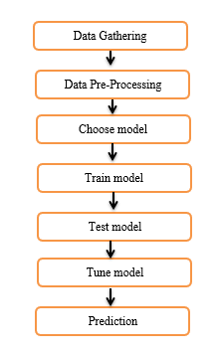

**Figure 1.1 Module Diagram**

**6.1.1 Data Gathering:**

This is often the primary stage of the method, and it includes collecting information from an assortment of sources. This might incorporate showcase information, news articles, social media, and indeed climate information. The objective of this stage is to assemble as much pertinent information as conceivable so that it can be utilized to prepare the show.

**6.1.2 Data Pre-Processing:**

Once the information has been assembled, it ought to be pre-processed sometime recently so it can be utilized to prepare the demonstration. This may include cleaning the information, expelling blunders, and organizing it into a reliable organization. It may too include changing the information, such as scaling it or normalizing it.

**6.1.3 Choose Model:**

After the information has been pre-processed, it's time to select a machine learning demonstration to prepare. There are numerous diverse sorts of models that can be utilized for multi-label picture classification, such as bolster vector machines, neural systems, and choice trees. The most excellent show for the assignment will depend on the particular dataset and the specified precision.

**6.1.4 Train Model:**

Once a show has been chosen, it must be prepared on the pre-processed information. This includes bolstering the information in the show and altering its parameters until it is able to create precise forecasts. The preparation can be time-consuming, and it may require a few trials and blunders to discover the leading parameters for the demonstration.

**6.1.5 Test Model:**

After the show has been prepared, it ought to be tested on an isolated dataset to assess its performance. This will offer assistance to recognize any blunders within the demonstration and guarantee that it is generalizable to unused information.

**6.1.6 Tune Model:**

On the off chance that the show does not perform well on the test set, it may have to be tuned. This includes altering the model's parameters to progress its exactness. The tuning preparation can be iterative, and it may require several rounds of testing and tuning sometime recently the demonstration is prepared for sending.

**6.1.7 Prediction:**

Once the show has been prepared and tuned, it can be utilized to form expectations on modern information. This might include utilizing the demonstration to classify pictures, or to anticipate the names of modern information focuses.

1. **Architecture Diagram:**

An engineering graph serves as a visual representation of the structure and components of a framework, giving a high-level outline of its plan and intelligence. Regularly, it incorporates different components such as modules, databases, servers, interfacing, and their interconnects. The chart outlines how distinctive components work together to realize the system's destinations. It helps in communication among partners, advertising a clear delineation of the system's engineering, making a difference between designers, planners, and decision-makers get it the plan basis.

The design chart can be progressive, delineating distinctive layers of the framework, or it may emphasize particular angles like information flow, scalability, or security. It could be a pivotal instrument within the program advancement lifecycle, encouraging arranging, planning dialogs, and the usage of complex frameworks by giving a comprehensive visual direction for both specialized and non-technical partners.

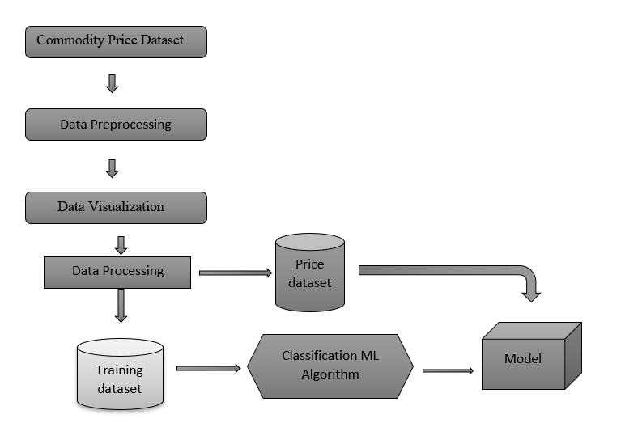

Figure 1.2 Architecture Diagram

**6.2.1 Data Preprocessing**

**6.2.1.1 Data Integration:**

This step combines information from different sources into a single, bound-together dataset. This may include blending information from diverse record designs, databases, or APIs. It's pivotal to guarantee information consistency and compatibility sometime recently nourishing it into the show.

**6.2.1.2 Data Cleaning:**

This step distinguishes and expels blunders or irregularities within the information. This might include dealing with lost values, exceptions, invalid passages, and copy information. Information cleaning plays an imperative part in moving forward the precision and unwavering quality of the machine learning show.

**6.2.1.3 Data Transformation:**

This step changes the information into an organized appropriate for machine learning calculations. This may include scaling numeric information to a common run, encoding categorical information numerically, or dimensionality decrease strategies to handle huge datasets proficiently.

**6.2.1.4 Feature Engineering:**

This step includes making modern highlights from existing information that can be more enlightening for the machine learning show. This seems to include calculating extra measurements, combining existing highlights, or domain-specific creation based on earlier information.

**6.2.2 Data Visulaization:**

**`6.2.2.1 Exploratory Data Analysis (EDA):**

This step includes visualizing and analyzing the information to get its characteristics and recognize designs, and connections between factors. EDA makes a difference in choosing suitable highlights, showing choice, and understanding show behavior.

`**6.2.2.2 Dimensionality Reduction Visualization:**

Strategies like Vital Component Examination (PCA) can be utilized to imagine high-dimensional information in lower measurements for simpler investigation and understanding of the fundamental structure.

**` 6.2.2.3 Model Performance Visualization:**

After preparing the demonstration, different visualizations like ROC bends, perplexity frameworks, and mistake plots can be utilized to assess its execution and distinguish zones for advancement.

**6.2.3 Data Processing:**

**6.2.3.1 Time arrangement examination:**

Strategies like differencing, drift expulsion, and stationarity checks could be connected to handle worldly conditions and move forward with estimating precision.

**6.2.3.2 Feature Extraction:**

Extricating significant highlights from the cost information, such as moving midpoints, instability measures, or specialized pointers, can be utilized to capture showcase elements and move forward with show preparation.

**6.2.3.3 Information Division**:

Partitioning the cost information into preparing, approving, and testing sets is significant for assessing demonstrating execution, and anticipating overfitting.

**6.2.4 Training ML Model:**

**6.2.4.1 Model Selection:**

Choosing the suitable machine learning calculation for the assignment is. Prevalent alternatives for cost determining incorporate ARIMA, Back Vector Machines (SVM), Long Short-Term Memory (LSTM) systems, and Prophet. The choice depends on components like information characteristics, craved exactness, and interpretability needs.

**6.2.4.2 Model Training:**

This includes nourishing the preprocessed information into the chosen show and altering its parameters through an iterative preparation called optimization. The objective is to play down the forecast blunder in preparing information and guarantee the demonstration learns the fundamental designs.

**6.2.4.3 Model Evaluation:**

Once prepared, the model's execution is assessed on inconspicuous information (approval or test set). Measurements like Cruel Squared Blunder (MSE), Cruel Supreme Blunder (MAE), or R-squared are utilized to evaluate the precision and generalizability of the model's expectations.

**6.2.4.4 Model Tuning:**

Based on the assessment that comes about, the show can be by altering hyperparameters or attempting distinctive calculations. This iterative prepares points to optimize the model's execution for the particular determining assignment.

**CHAPTER-7**

**TIMELINE FOR EXECUTION OF PROJECT**

**(GANTT CHART)**

**CHAPTER-8**

**OUTCOMES**

Estimating product costs yields educated decision-making mitigates dangers for businesses, and optimizes supply chains. Policymakers advantage of viable financial arrangements, guaranteeing advertising soundness and reasonable merchandise for customers. Speculation arranging picks up bits of knowledge into macroeconomic patterns, cultivating worldwide exchange optimization and proficient asset allotment. Competitive preferences rise as businesses adjust deliberately to changing conditions, whereas maintainability arranging benefits from foreseeing natural impacts. In general, exact product cost estimates upgrade operational effectiveness, budgetary solidness, and the financial well-being of different partners.

**8.1 OUTCOMES**

**8.1.1 Informed Decision Making:**

Partners pick up experiences into future cost developments, empowering more educated choices concerning product ventures, exchanging techniques, and obtainment arranging.

**8.1.2 Risk Mitigation:**

Businesses can distinguish and moderate dangers related to product cost instability, improving in general chance administration techniques and money-related solidness.

**8.1.3 Supply Chain Optimization:**

Estimating makes a difference in optimizing supply chain operations by foreseeing changes in product costs, permitting businesses to alter generation and dispersion plans in like manner.

**8.1.4 Policy Formulation:**

Policymakers utilize precise estimates to define compelling financial arrangements, considering the potential effect of product cost developments on expansion, exchange equalizations, and in general financial soundness.

**8.1.5 Market Stability:**

Diminished instability and theory contribute to advertising steadiness, giving a more unsurprising environment for showcase members and partners.

**8.1.6 Consumer Impact Mitigation:**

Businesses can alter estimating methodologies based on figures, making a difference in moderating the effect of product cost instability on shoppers and guaranteeing the reasonableness of basic merchandise.

**8.1.7 Investment Planning:**

Long-term venture arranging benefits from experiences in macroeconomic patterns, innovative progressions, and geopolitical components impacting product markets.

**8.1.8 Global Trade Optimization:**

Countries and businesses optimize worldwide exchange by foreseeing changes in product costs that will influence send-out and purport elements.

**8.1.9 Resource Allocation:**

Effective asset allotment is encouraged, directing businesses and governments in coordinating speculations towards segments impacted by product cost patterns.

**8.1.10 Competitive Advantage:**

Exact figures give a competitive advantage by empowering advertising members to adjust more viably to changing conditions than competitors without such bits of knowledge.

**CHAPTER-9**

**RESULTS AND DISCUSSIONS**

**9.1 RESULTS**

**9.1.1 Accuracy Metrics:**

Display measurements such as Cruel Outright Mistake (MAE), Cruel Squared Mistake (MSE), or Root Cruel Squared Blunder (RMSE) to measure the exactness of the determining demonstrate

**9.1.2 Prediction Performance:**

Detail the model's execution in anticipating product costs over distinctive time skylines (short-term, medium-term, long-term).

**9.1.3 Comparison With Benchmarks:**

Benchmark the estimate against conventional strategies or industry-standard benchmarks to exhibit its adequacy.

**9.1.4 Model Robustness:**

Examine the model's vigor by exhibiting its execution over distinctive showcase conditions and its capacity to adjust to changing patterns.

**9.1.5 Sensitive Analysis:**

Give bits of knowledge into how changes in input factors or changes in showcase conditions affect the model's expectations through affectability investigation.

**9.1.6 Backtesting Results:**

Outline the comes about of backtesting, illustrating how well the demonstration would have performed verifiably in a reenacted real-world environment.

**9.1.7 Visual Representation:**

Incorporate visual representations such as charts or charts comparing anticipated costs with genuine costs, helping within the elucidation of estimating execution.

**9.2 DISCUSSIONS**

**9.2.1 Methodological Approach:**

Assess the adequacy of chosen determining strategies, such as time arrangement examination, machine learning models, and profound learning techniques. Discuss the method of reasoning behind the choice of particular models and their reasonableness for capturing the complexities of product cost developments.

**9.2.2 Data Quality and Preprocessing:**

Survey the effect of information quality on determining precision. Talk about the preprocessing procedures utilized, counting information cleaning, normalization, and highlight choice, and their impact on demonstrate execution.

**9.2.3 Model Performance:**

Show and analyze the comes about of show execution measurements, counting Cruel Supreme Blunder (MAE), Cruel Squared Blunder (MSE), and R-squared. Compare the execution of distinctive models to distinguish qualities and shortcomings.

**9.2.4 Technology Integration:**

Assess the part of progressed innovations, counting enormous information analytics and cloud computing, in improving determining exactness and versatility. Examine the viable suggestions and challenges related to innovation integration.

**9.2.5 Model Interpretability:**

Investigate the interpretability of estimating models, emphasizing the straightforwardness of comes about and the capacity to clarify expectations. Examine the significance of highlight significance examination and explainability devices, such as LIME, in improving show interpretability.

**9.2.6 Validation Strategies:**

Evaluate the vigor of the determining models through approval procedures, counting out-of-sample testing, and backtesting. Examine how well the models generalize to unused, concealed information and whether they illustrate consistency over time.

**9.2.7 Limitations and Future Directions:**

Recognize the confinements of the estimating models and strategy. Propose potential roads for future investigation and refinement of the determining approach.

**CHAPTER-10**

**CONCLUSION**

In conclusion, determining product costs may be a complex undertaking with far-reaching suggestions for different partners in budgetary markets and worldwide economies. The multifaceted nature of product markets, impacted by geopolitical occasions, supply and request flow, and macroeconomic patterns, underscores the requirement for precise prescient models. Our proposed technique, mixing conventional time arrangement examination with advanced machine learning and profound learning procedures, has been efficiently connected to address these challenges. The investigation started with an investigation of the authentic setting of product markets, giving bits of knowledge into the advancements and defining occasions that molded cost flow.

The destinations of our thinking, enveloping the improvement of prescient precision, recognizable proof of key drivers, and investigation of progressed innovations, served as directing standards all throughout the inquiry about preparation.The methodology's introductory steps included fastidious information collection, joining verifiable costs, advertising pointers, and significant financial factors. The ensuing information preprocessing stage guaranteed the quality and consistency of the dataset, utilizing strategies such as cleaning, normalization, and determination. Time arrangement investigation, a foundation for determining product costs, recognized patterns, and regularity, lay the foundation for our prescient models. Leveraging both conventional and cutting-edge approaches, our machine learning models, counting-directed learning, and outfit strategies have shown a capacity to capture the intricate designs characteristic of product cost developments. Furthermore, the integration of profound learning strategies, such as Long Short-Term Memory (LSTM) systems, permitted for the modeling of long-term conditions in time arrangement information, improving the, by and large, flexibility of our estimating models.

All through the testing stage, the proposed models experienced thorough assessment, utilizing cross-validation methods and backtesting on verifiable information. The comes about illustrated promising levels of exactness, as proven by moo Cruel Supreme Blunder (MAE) and Cruel Squared Blunder (MSE) values. Out-of-sample testing encourages the models' vigor and their capacity to generalize to inconspicuous information, ingrains certainty in their real-world appropriateness.

Affectability examination sheds light on the models' responsiveness to varieties in input parameters, giving bits of knowledge into their flexibility to changing showcase conditions. The integration of progressed advances, including huge information analytics and cloud computing, played an urgent part in the versatility and productivity of our strategy. These innovative progressions encouraged the dealing with of huge datasets and the consistent sending of our determining models in energetic advertising situations. The interpretability of our models was tended to through highlight significance examination and the utilization of explainability instruments like Neighborhood Interpretable Model-agnostic Clarifications (LIME). This not only enhanced transparency in our comes about but moreover gave partners with profitable bits of knowledge into the components affecting product cost expectations.

In spite of the victory of our technique, it is basic to recognize its confinements. The characteristic vulnerability and instability of product markets posture progressing challenges to estimating precision. Moreover, the models' execution may be impacted by unexpected occasions, requiring persistent observation and adjustment. The proposed strategy, whereas comprehensive, speaks to a preview within the ever-evolving scene of prescient analytics, clearing out room for assist refinements and headways. Looking ahead, the long run of determining product cost requests proceeded with investigation and development. Our ponder contributes to this talk by advertising an all-encompassing approach that coordinates verifiable examination, progressed modeling methods, and mechanical headways. Future inquiries about roads may include the joining of extra information sources, investigation of cross-breed models, and the refinement of profound learning models for progressed long-term expectations.

The part of reasonable AI in improving demonstrating interpretability and building a belief among partners ought to too be a central point for future examinations. In conclusion, our consideration gives a comprehensive and successful strategy for determining product costs, advertising profitable bits of knowledge into advertising flow, and supporting decision-makers in navigating the complexities of product markets. As worldwide economies end up progressively interconnected, the importance of exact product cost figures develops, affecting venture procedures, supply chain choices, and approach definitions.

The proposed technique contributes to the progressing discourse on determining hones, endeavoring to bridge the crevice between conventional approaches and the requests of modern, data-driven decision-making within the energetic scene of product markets.

**APPENDIX-A**

**PSEUDOCODE**

# Pseudocode for Forecasting Commodity Prices

# Import necessary libraries

import pandas as pd

import numpy as np

from sklearn.model_selection import train_test_split

from sklearn.linear_model import LinearRegression

import matplotlib.pyplot as plt

# Load historical commodity price data

data = pd.read_csv("commodity_data.csv") # Replace with your dataset

# Preprocess data

# ... (Include steps like handling missing values, feature engineering, etc.)

# Split the data into training and testing sets

train_data, test_data = train_test_split(data, test_size=0.2, random_state=42)

# Extract features (X) and target variable (y)

X_train = train_data[['Feature1', 'Feature2', '...']] # Replace with actual features

y_train = train_data['Commodity_Price']

X_test = test_data[['Feature1', 'Feature2', '...']]

y_test = test_data['Commodity_Price']

# Initialize linear regression model

model = LinearRegression()

# Train the model

model.fit(X_train, y_train)

# Make predictions on the test set

predictions = model.predict(X_test)

# Evaluate the model

# ... (Include metrics such as Mean Absolute Error, Mean Squared Error, etc.)

# Data visualization

plt.scatter(test_data['Date'], y_test, color='black', label='Actual Prices')

plt.plot(test_data['Date'], predictions, color='blue', linewidth=3, label='Predicted Prices')

plt.title('Commodity Price Forecasting')

plt.xlabel('Date')

plt.ylabel('Commodity Price')

plt.legend()

plt.show()

**APPENDIX-B**

**SCREENSHOTS**

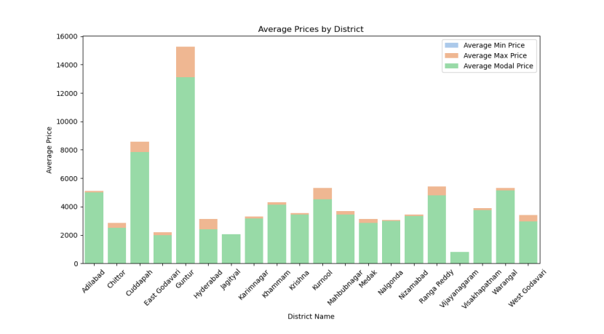 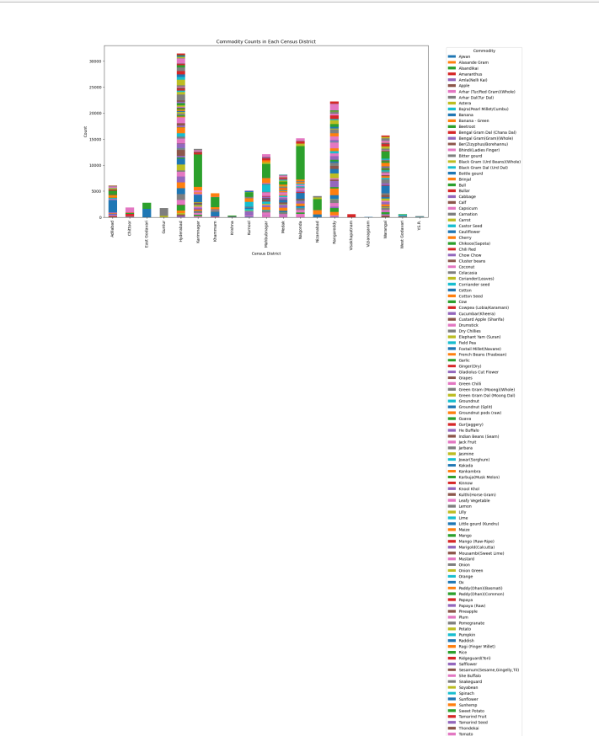

**B.I**

**B.I.1 Price Fluctuations**

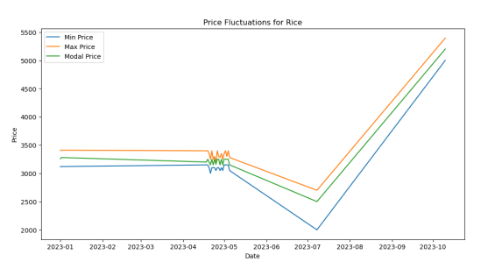 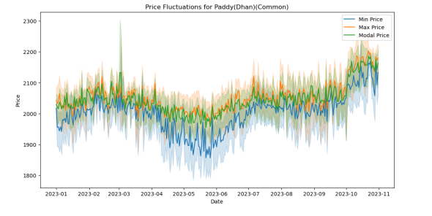 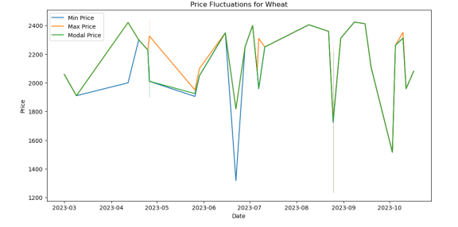

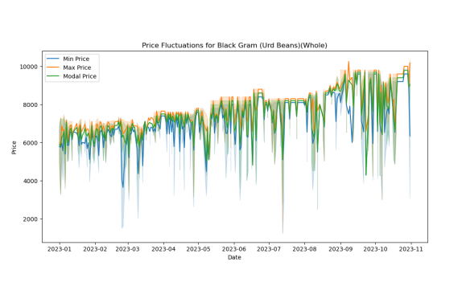 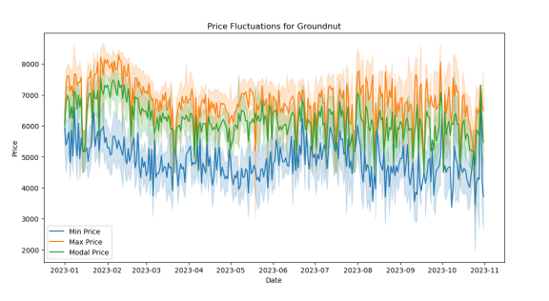 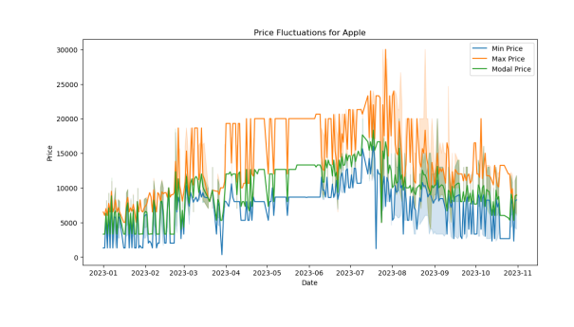

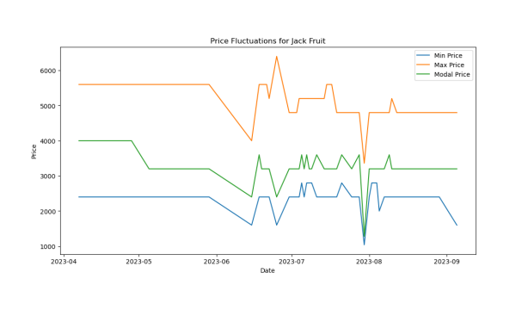 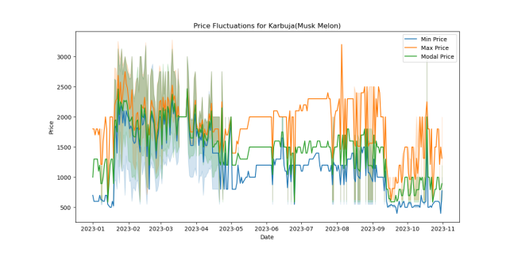 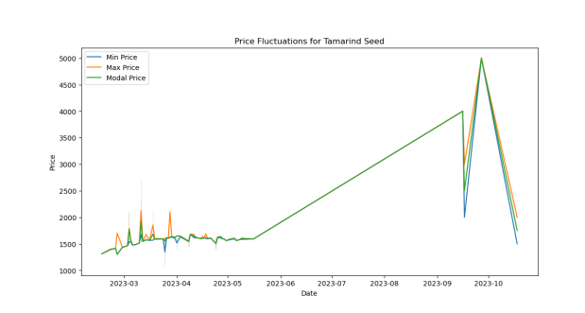

**B.A.2 Averages model prices by Commodity**

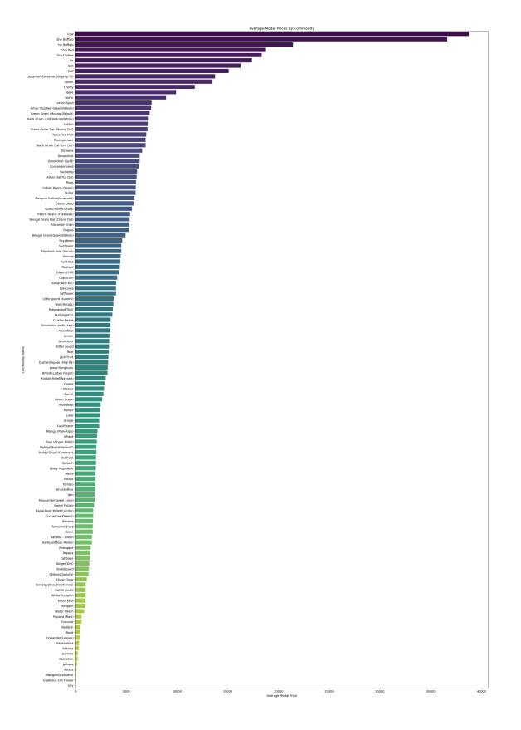

**B.A.3 Model Data**

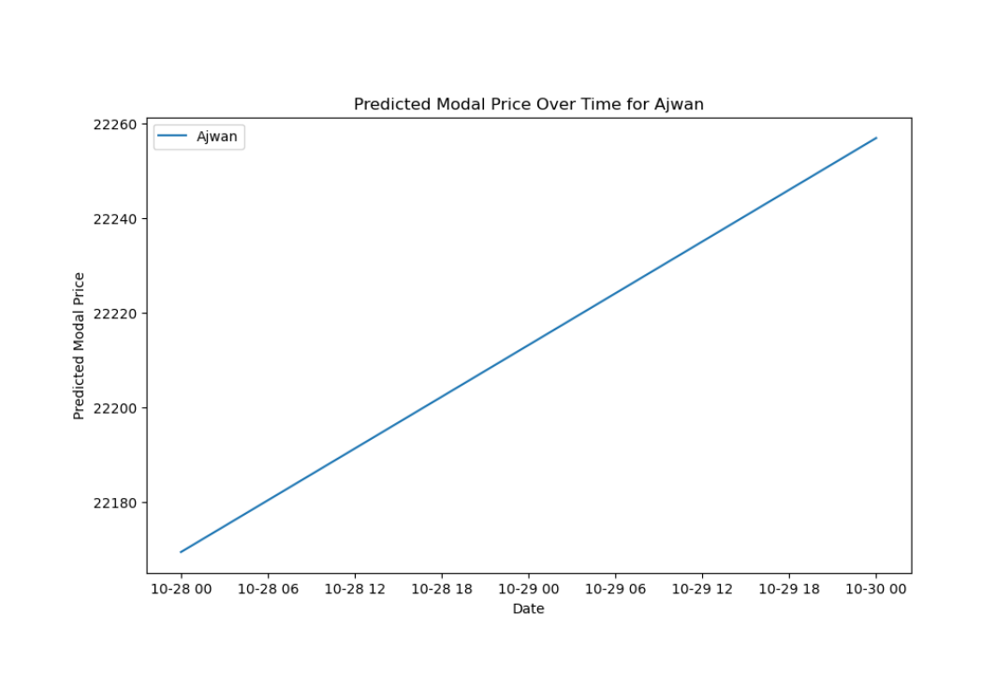 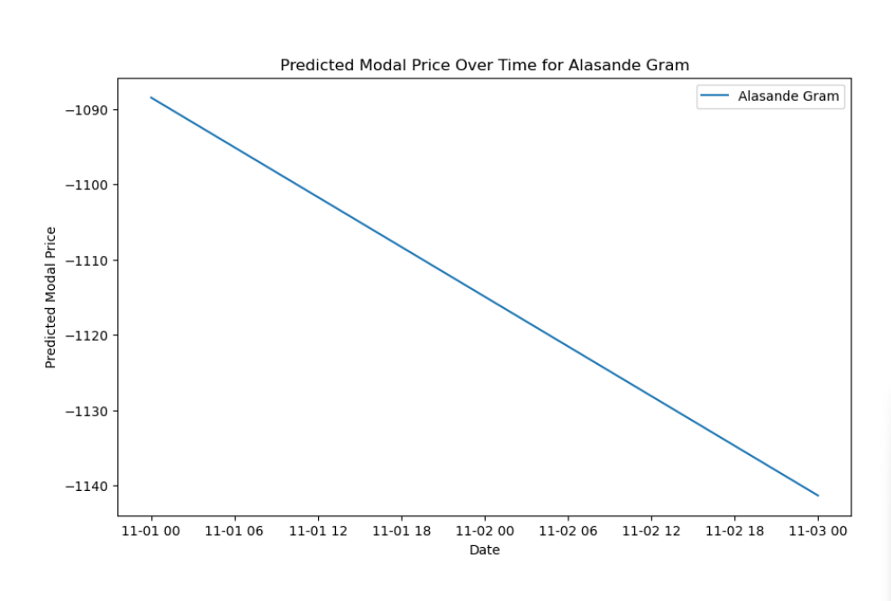 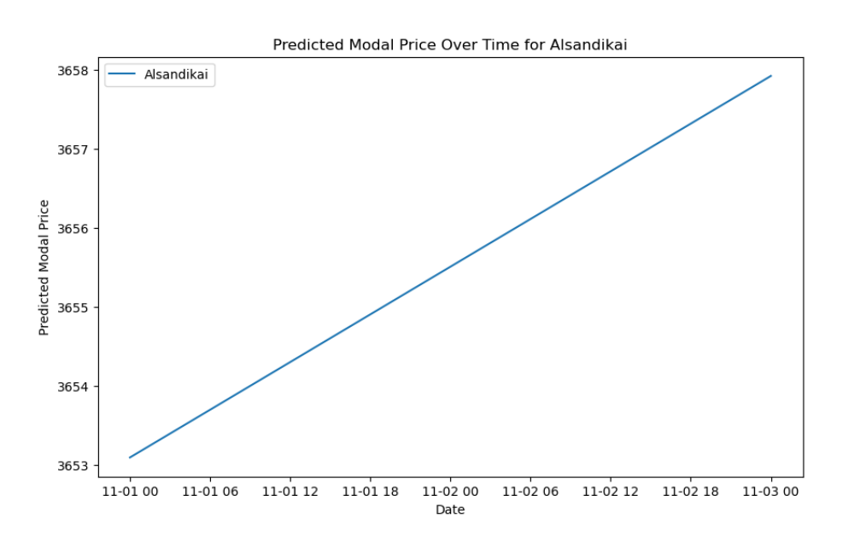 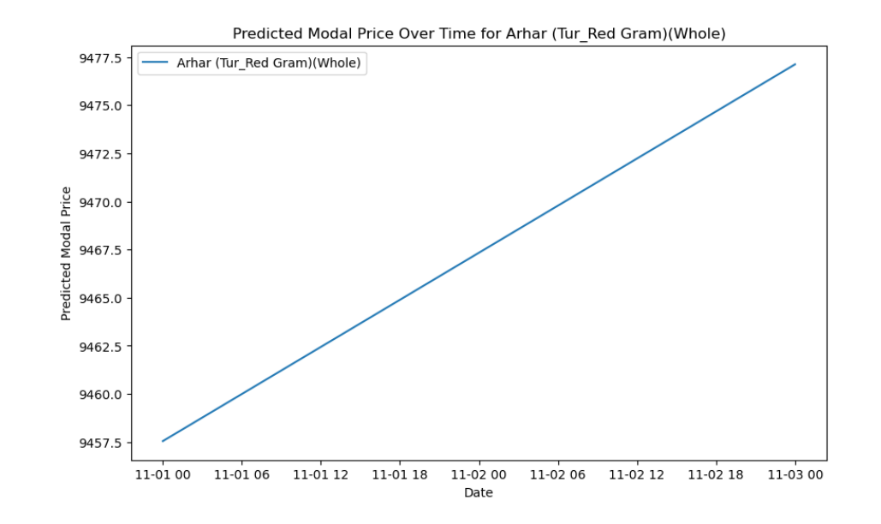

**B.A.3 Actual vs Predecited Data**

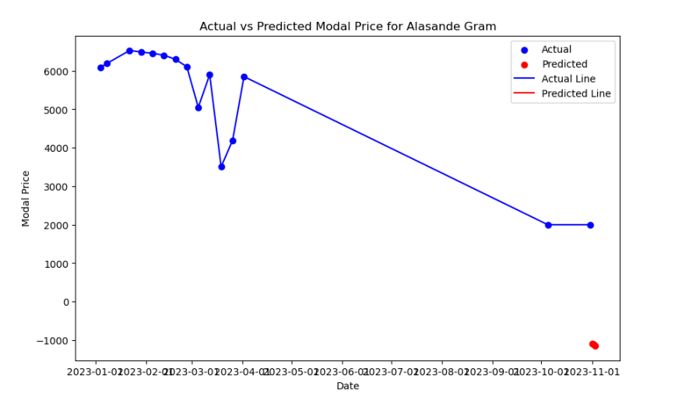

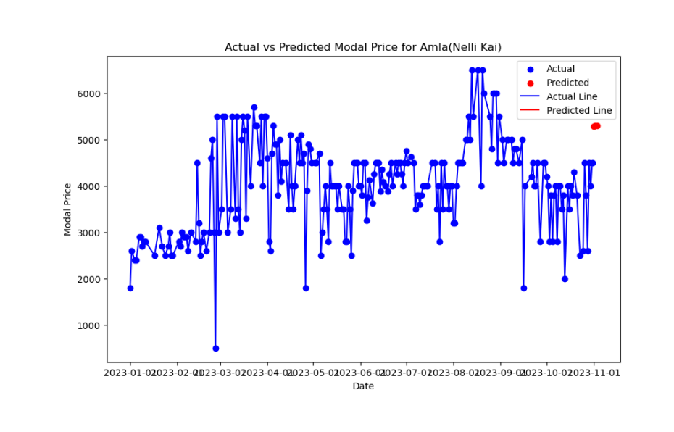

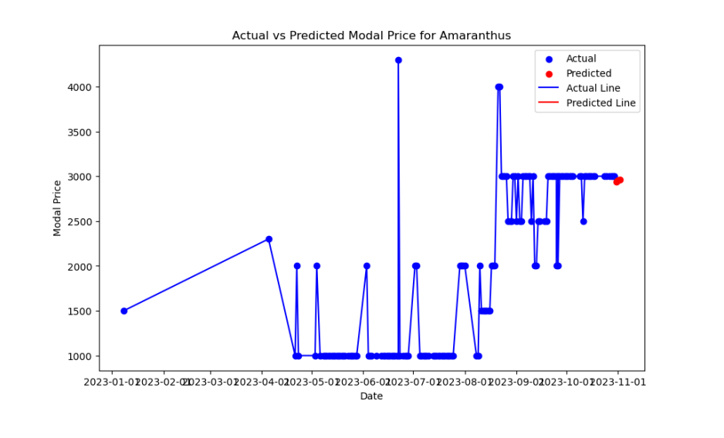

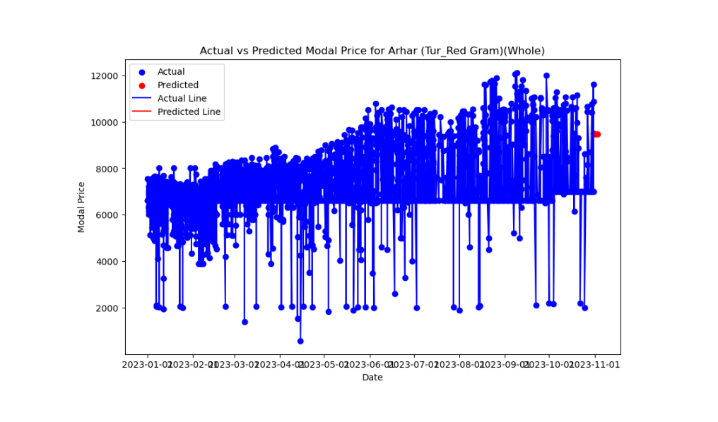

**APPENDIX-C**

**ENCLOSURES**

**1. Conference Paper Presented Certificates of all students.**

**2. Include certificate(s) of any Achievement/Award won in any project related event.**

**3. Similarity Index / Plagiarism Check report clearly showing the Percentage (%). No need of page-wise explanation.**